**Customer Age Distribution Analysis:**

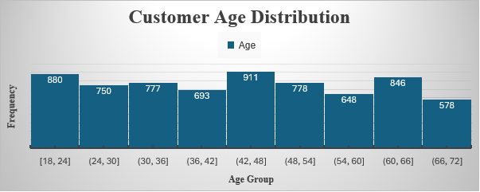

**Key Insights**

The analysis of customer age distribution reveals key trends:

1. **Dominant Age Group:** Customers aged 42–48 lead with the highest frequency (911), indicating strong engagement from this segment.
2. **Young Adults (18–24):** The second-largest group (880), showing a robust presence of younger customers.
3. **Lowest Engagement:** The senior age group (66–72) has the least representation (578).
4. **Notable Trends:** A dip is observed in the age ranges of 36–42 (693) and 54–60 (648), while there is a resurgence in the 60–66 range (846).

**Variability in Purchase Amounts Across Categories**

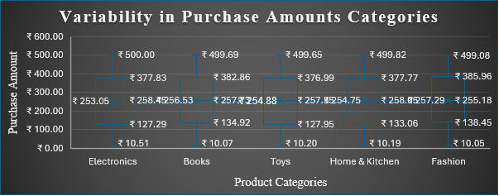

**Key Insights**

The box plot showcases the variability in purchase amounts for different product categories:

1. **Median Purchase Amounts:** All categories have similar median values, ranging around ₹254–₹258, suggesting a consistent spending pattern across products.
2. **Maximum Purchases:** Electronics shows the highest upper range (₹500.00), indicating potential for larger purchases in this category.
3. **Minimum Purchases:** Fashion and Toys exhibit the lowest minimum values (~₹10), reflecting smaller purchases.
4. **Interquartile Range (IQR):** Electronics and Home & Kitchen have wider IQRs, indicating more variability in spending. In contrast, Fashion shows a narrower range, suggesting more consistent purchase behavior.
5. **Outliers:** Minimal presence of extreme values, reflecting a balanced purchase trend across categories.

**Customer Distribution by Region**

1. **North Leads:** The North region has the largest share (26%).
2. **East and West Equal:** Both regions contribute 25% each.
3. **South Slightly Lower:** The South region accounts for 24%.
4. **Insight:** The distribution is relatively balanced, with a slight lead by the North.

**Balanced Revenue Distribution Across Product Categories**

**Insights**

1. **Equal Revenue Contribution**: Each product category contributes approximately **20%** to the overall revenue, indicating a balanced distribution of revenue across all categories.
2. **Revenue Figures**:
   * **Books**: $1,355,854.68
   * **Electronics**: $1,389,447.52
   * **Fashion**: $1,382,888.62
   * **Home & Kitchen**: $1,421,337.34
   * **Toys**: $1,397,337.25
3. **Key Observation**: Although all categories contribute equally percentage-wise, **Home & Kitchen** has the highest absolute revenue, and **Books** the lowest, though the differences are relatively small.

**Age and Regional Impact on Purchase Behavior**

**Key Insights**

1. **Age Group Trends**:
   * The proportion of purchases increases steadily with age, peaking in the **60-66** age group and slightly tapering off for the **66-72** group.
   * Younger age groups (18-24) contribute the least to purchases.
2. **Regional Patterns**:
   * **South** and **West** regions contribute consistently higher proportions compared to the **North** and **East**.
   * The **South** region has its peak contribution in the **60-66** age group (16.99%).
   * The **West** has a similar peak in the **60-66** age group (15.29%).
3. **Dominant Contributors**:
   * The **South** region consistently leads among all regions, particularly in older age groups.
   * The **East** region consistently contributes the least proportionally across all age groups.
4. **Age Group 48-54**: Shows the highest proportional growth compared to prior age brackets, particularly in the **South** and **West** regions.

**Regional Revenue Distribution by Gender**

**Insights:**

1. **Highest Revenue by Gender**:
   * **North** region: Males contribute the most revenue (~640,000), followed by females.
   * **"Other"** gender contributes significantly across all regions, particularly in the **East** and **West**.
2. **Regional Trends**:
   * The **North** region generates the highest overall revenue, led by males.
   * The **South** region has the lowest revenue across all genders, with females slightly leading.
3. **Gender Distribution**:
   * The **"Other"** category consistently generates notable revenue, often outperforming one or both binary genders in regions like **East** and **West**.

**Quarterly Revenue Trends by Product Category (2020–2024)**

**Insights:**

1. **Steady Growth**: The revenue trend for all product categories remains steady over the years (2020–2024) without drastic fluctuations.
2. **Dominant Category**: The "Toys" category consistently generates the highest revenue across all quarters, followed by "Home & Kitchen."
3. **Stable Segments**: Categories such as "Books" and "Electronics" show relatively constant revenue contributions over the observed period, with minimal growth or decline.
4. **Seasonality**: There is no significant indication of seasonality or large quarterly variations in revenue trends.

**Analysis of Purchase Amount Across Age Groups**

**Insights**

1. **Weak Correlation**: The scatter plot shows a very weak positive correlation between age and purchase amount, as indicated by the low R2 value (0.0014).
2. **Flat Trendline**: The regression line has a minimal slope (0.3369), suggesting that age has little to no impact on purchase amounts.
3. **Uniform Distribution**: Purchase amounts are relatively uniform across all age groups, with no significant variation for any specific group.
4. **Average Spending**: Most purchases fall within the ₹200–₹300 range, regardless of age.
5. **High Variability**: The scatter plot reveals wide variability in purchase amounts across different age groups.

**Total Purchases by Product Category**

**Insights:**

1. **Top Category:** The "Home & Kitchen" category leads with the highest total purchases (₹5,572), indicating strong consumer interest in this segment.
2. **Consistent Performance:** Categories such as "Books" (₹5,471), "Electronics" (₹5,491), and "Fashion" (₹5,479) show relatively close total purchase values, indicating balanced demand across these segments.
3. **Lowest Total:** The "Toys" category has the lowest total purchase value (₹5,384). However, the difference compared to other categories is minimal.
4. **Close Purchase Volumes:** The purchase volumes across all categories are relatively close, with a difference of less than ₹200 between the highest and lowest categories, reflecting a balanced distribution of consumer interest.

**Quarterly Purchase Trends (2020–2024)**

**Insights:**

1. The overall trend is relatively stable, with slight fluctuations in the number of purchases over the 4 years.
2. Peak purchases were observed in **Q1 2022 (1444 purchases**).
3. A significant decline is noticeable in **Q4 2024**, where purchases dropped to 1141—the lowest across the 4-year period.
4. Yearly variations show consistent activity, with occasional minor dips, but the overall volume remains near 1400 purchases quarterly.

**Average Purchase Behavior Across Age Groups**

**Insights:**

1. The average purchase amount fluctuates across different age groups, ranging between ₹250.82 and ₹257.49.
2. The highest average purchase amount is observed in the 66–72 age group (₹257.49).
3. The lowest average purchase amount is recorded in the 48–54 age group (₹250.82).
4. Younger age groups (18–24) and older age groups (66–72) show higher average spending compared to middle-aged groups (24–60).
5. There is a noticeable dip in the 24–30 and 48–54 age groups compared to surrounding age brackets.